In the below examples, do NOT rely on this tag
CAUTION: This email originated from outside of EFSC. Do not click links or open attachments unless you recognize the sender and know the content is safe.
That tag often shows up even when we faculy and staff email each other from our school accounts.

Example 5
[Delete this line; put your answer here]

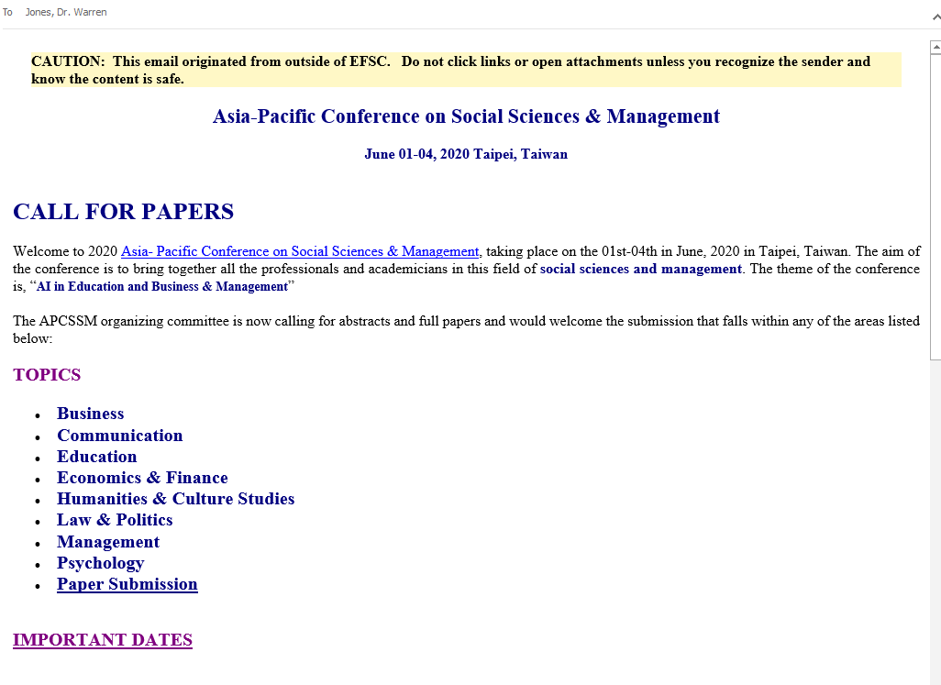
(Continued below)

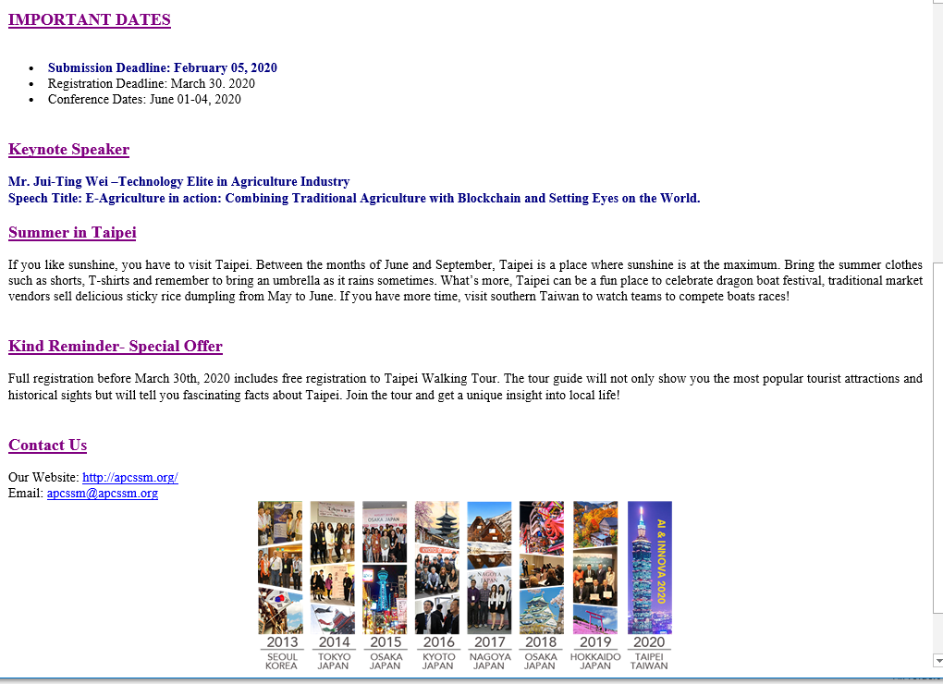

Example 6
[Delete this line; put your answer here]

Example 7
[Delete this line; put your answer here]

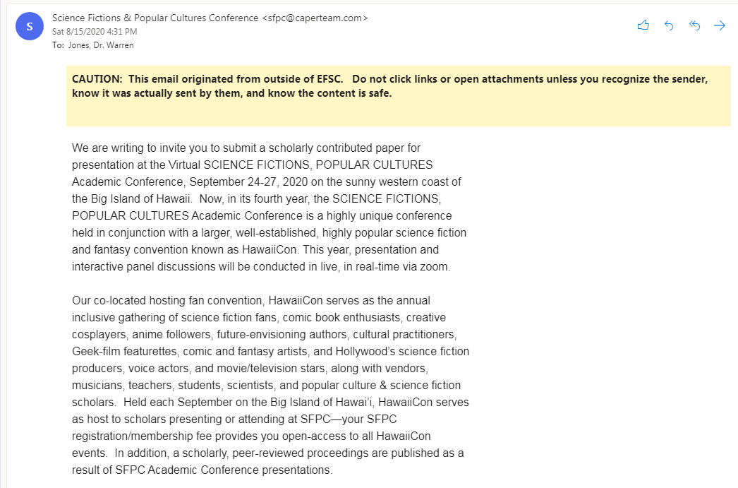

(Continued below)
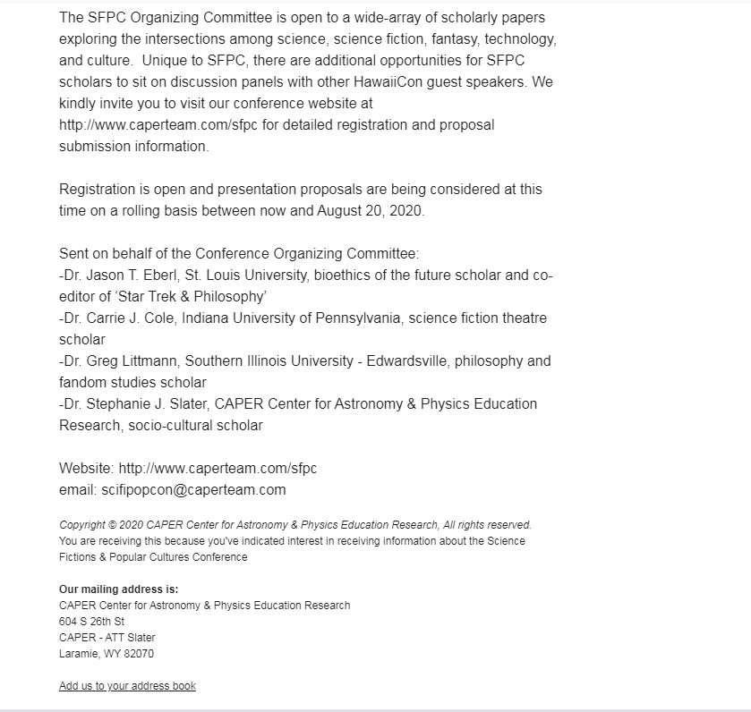

Example 8
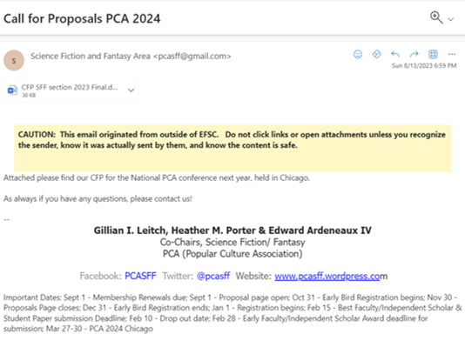
[Delete this line; put your answer here]
[continued below]
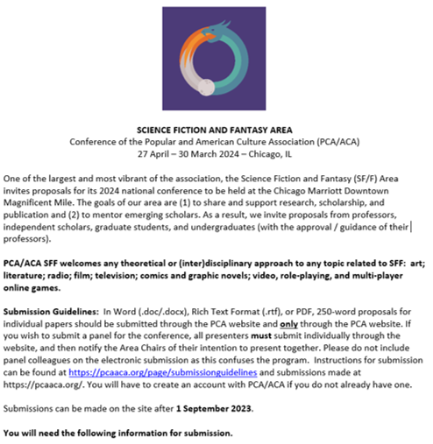
[continued below]

[continued below]
